🛒 Association Rule Mining Report
Author: Whitney Wairimu Gituara
Course: Data Warehousing and Mining
Dataset: Retail Store Sales

1. Introduction ✨
Association rule mining is a method used to find patterns or relationships between items in a dataset. In retail, it helps answer questions like:
- Which items are frequently bought together?
- Can we suggest products to customers based on their purchases?
This report explores these questions using a real-world retail dataset and the Apriori Algorithm to find frequent itemsets and association rules.

2. Dataset Description 📋
This project uses a real-world retail transaction dataset that captures the purchasing behavior of customers in a supermarket setting. Each record represents a unique customer transaction, showing which items were purchased together during a single visit.
The goal of this dataset is to explore product associations — identifying which items tend to appear together in customer baskets. This forms the foundation for market basket analysis and association rule mining.
Column Name | Description
Customer ID | Unique identifier for each customer
Transaction ID | Unique identifier for each transaction
Category | Item category (e.g., Beverages, Butchers, Milk Products)
Item | Name of the purchased item
Price Per Unit | Cost per unit of the item
Quantity | Number of units purchased
Total Spent | Total amount spent in the transaction
Discount Applied | Discount applied to the transaction
Dataset size: After cleaning, the dataset contains over 1,000 transactions and 8 main item types.
Data Cleaning Steps:
- Removed rows with missing Item values.
- Filled missing numeric columns (Price Per Unit, Quantity, Total Spent, Discount Applied) with 0.
- Standardized Item names to lowercase and removed extra spaces.
- Removed duplicate rows.

🧠 Dataset Purpose:
This dataset helps us:
- Understand which products are most frequently bought together.
- Identify customer purchasing patterns.
- Provide insights that can guide marketing strategies, store layouts, and cross-selling opportunities.

3. Frequent Itemset Mining 📈
We applied the Apriori Algorithm to find frequent combinations of items.

Top 8 Frequent Itemsets by Support
Itemset | Support
milk | 0.129
cea | 0.128
but | 0.126
food | 0.126
ehe | 0.125
fur | 0.124
bev | 0.121
pat | 0.120
Explanation:
- Support indicates how often an item appears in all transactions.
- For example, milk appeared in 12.9% of all transactions.

Top Frequent Itemsets Across Customers
Support | Itemset
1.0 | bev
1.0 | but
1.0 | cea
1.0 | ehe
1.0 | food
1.0 | fur
1.0 | milk
1.0 | pat
1.0 | bev, but
1.0 | cea, bev
Interpretation:
- All customers bought these items at least once.
- Helps identify most popular products for marketing and stock management.
Bar Chart:
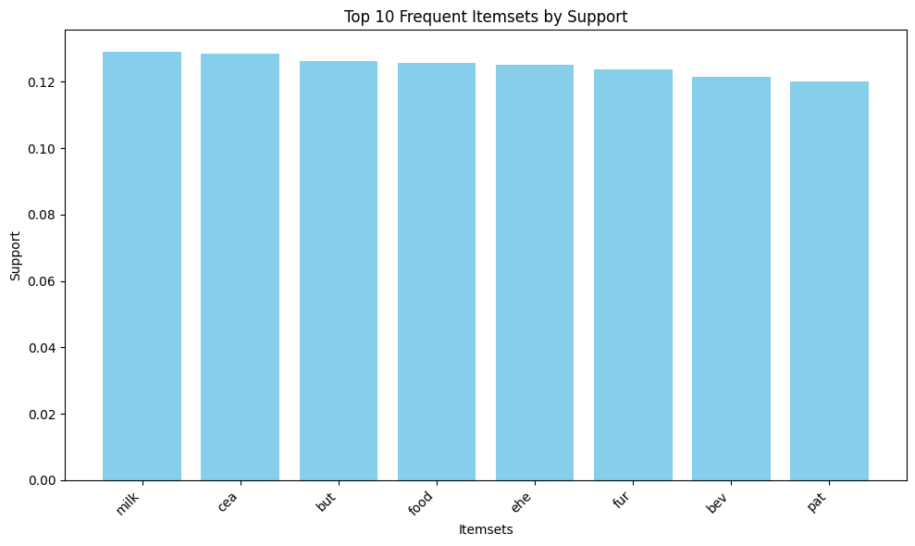

4. Association Rules 🔗
Association rules reveal how buying one item affects the likelihood of buying others.

Top 4 Interesting Rules
Rule | Support | Confidence | Lift | Interpretation
but → pat, fur, cea, food, bev, milk, ehe | 1.0 | 1.0 | 1.0 | Customers who buy butcher items also buy all other main items
bev → but | 1.0 | 1.0 | 1.0 | Customers who buy beverages also buy butcher items
food, milk → pat, fur, cea, bev, ehe, but | 1.0 | 1.0 | 1.0 | Customers who buy food and milk also buy most other items
food, bev → pat, fur, cea, milk, ehe, but | 1.0 | 1.0 | 1.0 | Customers who buy food and beverages also buy most other items

📏 Explanation of Metrics
In Association Rule Mining, several statistical measures are used to understand how items in a store are related to one another. These measures help identify which products are frequently bought together and how strong their relationships are. The three most common metrics are support, confidence, and lift.
Support measures how often certain items appear together in all transactions. It shows the overall popularity of an item or combination of items in the dataset. For example, if the support for the combination (milk, bread) is 0.3, it means that 30% of all transactions include both milk and bread. A higher support value indicates that the combination occurs more frequently, making it more relevant for business insights.
Confidence indicates the likelihood that a customer will buy one product given that they have already purchased another. It reflects how reliable or consistent a rule is. For instance, if the confidence for the rule (milk → bread) is 0.8, it means that 80% of the customers who bought milk also bought bread. High confidence suggests a strong tendency or buying pattern among customers.
Lift measures how much more likely two products are bought together compared to if they were independent of each other. It helps determine whether the relationship between two items is significant or just due to chance. A lift value greater than 1 means that the items are positively associated and are bought together more often than expected. A lift value close to 1 indicates no real association, while a lift less than 1 suggests a negative relationship, meaning that buying one item reduces the likelihood of buying the other.
Together, the three metrics, support, confidence, and lift, provide a complete picture of item relationships. Support shows frequency, confidence shows reliability, and lift shows strength of the relationship. When analyzed together, they help businesses make data-driven decisions such as product placement, promotions, and cross-selling strategies.

Frequency of Antecedents in Top 4 Rules
Item | Count in Top Rules
but | 2
bev | 2
food | 2
milk | 1
Bar Chart:
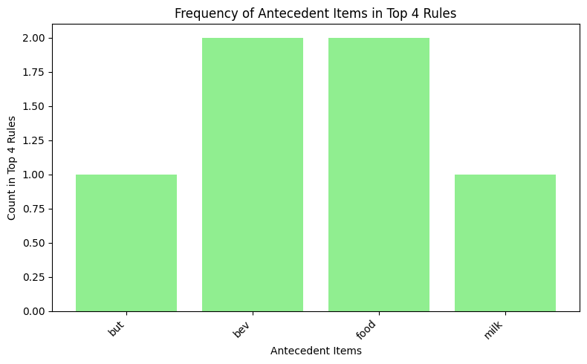

5. Insights & Business Implications 💡
- Customers buying butcher items often buy almost everything else, highlighting strong cross-selling opportunities.
- Popular items like milk, beverages, and food can be promoted together.
- Bundles or discounts on frequently bought-together items can increase overall sales.
- Helps in inventory planning to prevent stockouts of high-demand items.

6. Conclusion 🏁

🧾 This Report Demonstrates:
- Data Cleaning and Preparation 🧹
The report begins by loading and inspecting a real-world retail dataset containing customer purchase transactions. Since raw data often includes inconsistencies such as missing values, duplicates, or formatting errors, we perform data cleaning to ensure accuracy. This involves removing invalid records, standardizing item names, and preparing the data for analysis.
👉 Goal: To make sure the dataset is tidy, structured, and ready for mining patterns.
- Frequent Itemset Mining using the Apriori Algorithm 🧠
After cleaning, we apply the Apriori algorithm, a popular data mining technique used to identify groups of items (called itemsets) that frequently appear together in customer transactions.
👉 Goal: To find combinations of products that are often purchased together, for example, if many customers buy milk and bread together, this itemset will have a high frequency (or support).
- Generating Association Rules 🔍
From the frequent itemsets, we derive association rules, logical relationships that describe how the purchase of one item can imply the purchase of another.
👉 Example: If customers who buy milk also tend to buy cereal, we form a rule like {milk} → {cereal}.
Each rule is evaluated using metrics such as:
  - Support – how often the rule appears in the dataset.
  - Confidence – how often the consequent is true given the antecedent.
  - Lift – how much more likely items are bought together than by random chance.
👉 Goal: To uncover meaningful insights into buying behavior.
- Visualization and Interpretation of Results 📊
To make the results easier to understand, the report includes visualizations such as bar plots, heatmaps, and network graphs. These visualizations highlight the most frequent item combinations and show the relationships between products.
👉 Goal: To help retailers, marketers, and decision-makers quickly grasp which products are connected and how they can use this information for promotions, store layout, or product bundling.

